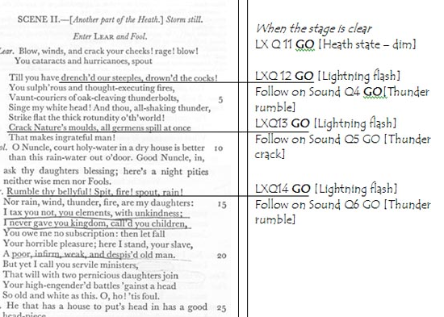
TA 445/545 STAGE MANAGEMENT

FALL 2020

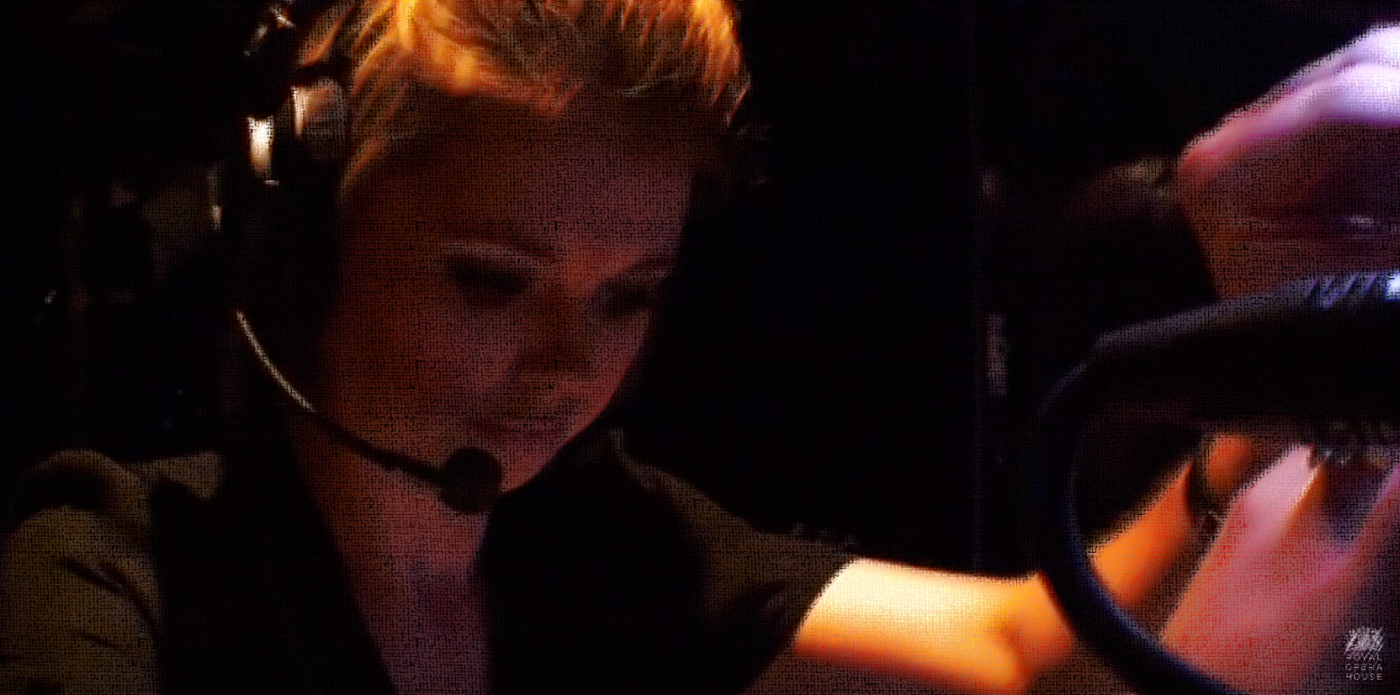

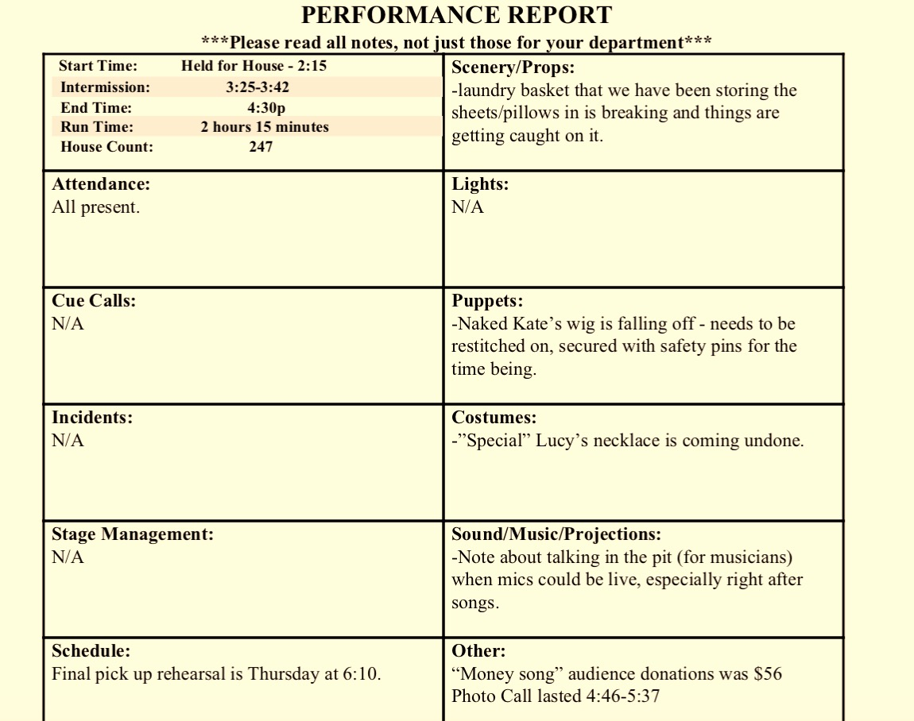
“HOW DO WE STAGE MANAGE DURING A PANDEMIC?”

T/TH 12:15-13:45
Some classes will be in person.
Some classes will be through Zoom.

